**SEARCH A BYTE FROM THE GIVEN STRING**

EXTRA SEGMENT

ARR DB 01H,02H,03H,04H,05H,06H

EXTRA ENDS

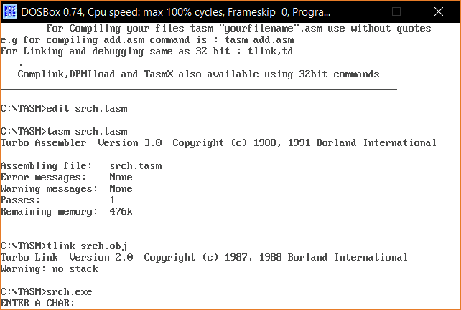

DATA SEGMENT

A1 DB 'NOT FOUND$'

A2 DB 'FOUND$'

MSG DB 'ENTER A CHAR: $'

DATA ENDS

CODE SEGMENT

ASSUME CS:CODE,ES:EXTRA,DS:DATA

START: MOV AX,DATA

MOV DS,AX

MOV AX,EXTRA

MOV ES,AX

LEA DI,ARR

LEA DX,MSG

MOV AH,09H

INT 21H

MOV AH,01H

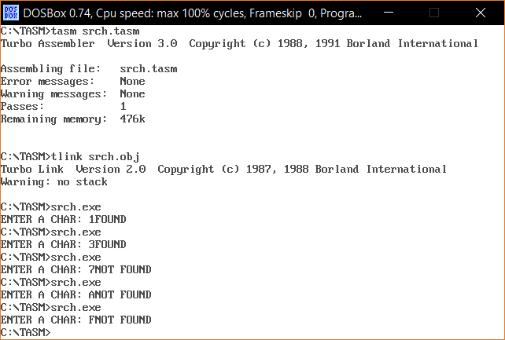 INT 21H

SUB AL,30H

MOV CX,06H

CLD

REPNE SCASB

JNZ NTF

LEA DX,A2

MOV AH,09H

INT 21H

JMP EXIT

NTF:LEA DX,A1

MOV AH,09H

INT 21H

EXIT:MOV AX,4C00H

INT 21H

CODE ENDS

END START